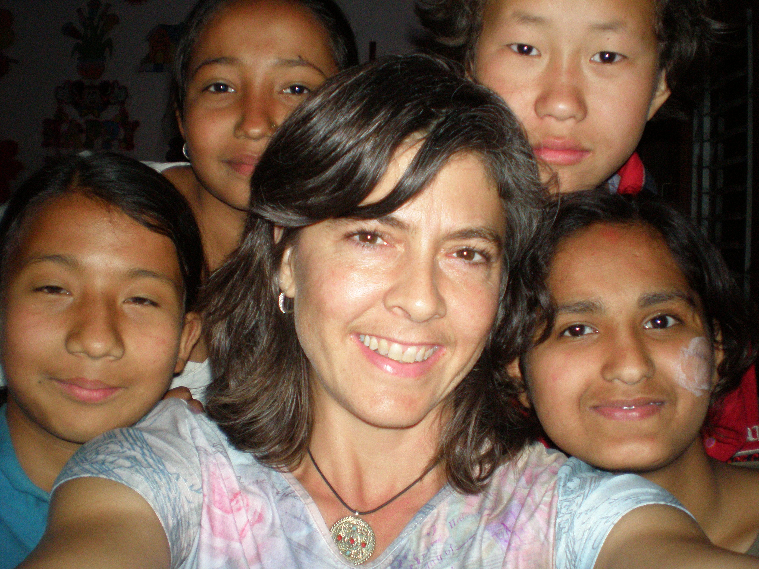

VIVA NEPAL!

Thanks again for all your support in helping get me across the world to help those in need. The trip was both exhilarating and eye opening. I learned that we take a lot for granted here in the US.

We worked 8 days in 4 different locations at Saathi shelters. We rotated through them, then returned for follow up visit. Each morning we met for breakfast to go over the days schedule, then packed our backpacks with supplies, homeopathy books, medical books, and other supplies and headed out on to the streets. We walked at least 2 miles and at most 6 miles each day to the shelter locations. The streets were mostly not paved, very busy traffic with those walking, on bike, motorcycle, rickshaw, mini-cars, buses, all honking and pushing along. Needless to say the pollution was a feat to overcome.

Two of the locations house women from the “entertainment” district. These shelters give them a place to come during the day and learn skills to make money in other ways. They were making rag rugs in one room and had a small sewing room for making clothing. We sat on mats on the floor with each of them and with the help of an interpreter, did our best to hear their story and their complaints. Many suffer from dehydration, stomach pain, back pain from heavy work/lifting, chronic cough, and general stress related anxiety and depression. Our treatments included listening with an open heart, giving some general health advice, some medicines and vitamins, but mostly acupuncture and homeopathy. . Our help was greatly appreciated. We did a couple of trainings here. One was on pain and how to use homeopathy and local ayurvedic oils/medicines to help. This was popular since these women even though they often work at night, also do all the cleaning, taking care of children, cooking, carrying water, and hand washing clothes for their households. All of this is hard on their backs and joints. The other training was hydrotherapy using the warming sock treatment. This treatment makes your immunes system strong to combat sickness, and the training helped the women understand how to take care of themselves and family when one has a fever by using this treatment. One of the doctors brought the material to make warming socks, they got very excited about this and began making the fleece socks right away.

Some of the funding from Saathi goes toward mini-loans which allow these women to go to school if they desire. One young lady recovered from prostitution and works now as a hairdresser after using her mini-loan for beauty school. She proudly showed off her beauty/massage salon to us. We got to meet her mother later in the trip, who has her own business, sitting on a blanket, selling trinkets, scarves and seeds to pilgrims heading to a Buddhist temple. She obviously came from a very humble beginning to where she is now. I found out later than college costs the equivalent of $14 US dollars per month. Boy what a little money from us can do for the Nepali people.

Next we worked at the domestic violence shelter. This was a bit more stressful emotionally, as I could feel the pain of these women merely by the look on their faces. Some of their stories I will not describe, one can only imagine. Domestic violence has only been illegal in this country for 1 year. It became illegal only 5 years ago, to put women in the cow shed when on their menses. One women had just had a child 2 weeks prior, she was in distress and we discovered an infection that needed immediate attention. Her fever was brought down quick with homeopathy, we treated the wound with calendula succus and did acupuncture for pain and infection. We left a large supply of first aid for this shelter, and prenatal vitamins. Such a small gift for a group in such need.

The childrens’ home brought a whole new host of experiences. I was greeted with sweet happy little voices “hello mam” “how are you mam?” Several children spoke fairly good English, a very polite form of proper English actually. They greeted us at the gate and all followed us up into the house giggling. The building was 4 stories high, set a mile away from the busyness of the main streets. I am guessing 50 children lived there permanently. Many have been there since infancy. The adults were full of love and care for these children, which seemed extremely well behaved compared to most schools in the US. Their rooms were bunk beds, 3-4 in a room and the bathrooms were very clean. Their diet was bread and milk tea for breakfast, daal bhaat (lentils and rice) for lunch and again for dinner. They ate meat on Saturdays and eggs twice per week. They all were lacking water however. Potable water is harder to come by there, it has to be carried a distance from up the road. They each only had 1-2 glasses per day, and many said they didn’t finish them. The frequent complaint of headaches was not a surprise once we realized they didn’t drink nearly enough. These children had complaints of itchy skin, headaches, some severe even passing out from head pain, eye strain, tooth aches, chronic cough, constipation, stomach pain. Amazing to see children undergo acupuncture, and oh how fast they respond to homeopathic medicines. My interpreter was Sharmilla, 13 years old, quite a lovely lady, dressed in pajama bottoms and a t-shirt. She caught on quickly.. “What is the matter? What makes it better? Worse? How long? When did it start? How painful?” I was amazed at how tuned-in to her young mates’ health she actually was. She seemed more like 16-17, than 13years old, the light in her eyes was sparkling.

All these girls quickly told us their dreams when asked. Sharmilla wants to be a doctor of social medicine and help people. Another wants to be a pilot, one a medical doctor, one a stewardess. I couldn’t help but feel the longing to grow, to fly out and see the world. Feeling this, it was tough saying good bye and leaving them behind. I am looking into how to set up scholarship funds for those that want to attend college.

Good news! Naturopaths International proposed to Saathi to allow us to fund an Ayurvedic Physician that will work full time rotating through the Saathi shelters and other domestic violence shelter organizations in Kathmandu. This type of medicine is similar to naturopathic principles and techniques, and it is more known and accepted in Nepal. Saathi agreed to the proposal and funding the project is next on the list. The price in US dollars to pay a doctor in Nepal is a fraction of what it is here. More details to come on this project. A local doctor will be hiring and overseeing this process.

My next venture in Nepal will be to visit Saathi again next year and also head west and work with the underprivileged in the country side. Less pollution, yet much more need in the area of health.

For information on how to buy certified fair trade Nepali items see www.mahaguthi.org



